Request for Quotation (RFQ) - Shopping For Works for Construction of a pontoon for mooring a new inspection vessel at the Institute of Marine Biology

Project Title: **Second Institutional Development and Agriculture Strengthening Project (MIDAS 2)**

Source of Funding: **World Bank loan**

Loan No: **8820-ME**

Contract Ref: **MNE-MIDAS2-8820-ME-RFQ-W-20-3.5.**

Date of Issue of Invitation: 01. October 2020

Dear Bidder,

1. The Ministry of Agriculture and Rural Development (Employer) hereby invites you to submit a quotation for the following works: Construction of a pontoon for mooring a new inspection vessel at the Institute of Marine Biology

2. To assist you in the preparation of your price quotation we enclose the necessary specifications, bill of quantities and drawings, form for submitting the quotation and a draft contract form.

**You shall submit the Price Quotation with the Form of Quotation electronically, on a following e-mail:** [**mirko.ljesevic@mif.gov.me**](mailto:mirko.ljesevic@mif.gov.me) **as a scanned document in PDF format, with a stamp and signature, and state in the subject:**

**"Quotation for construction of a pontoon for mooring a new inspection vessel", ref.no. MNE-MIDAS2-8820-ME-RFQ-W-20-3.5.**

Address of the Employer related to procurement process for this works are as follows:

**Ministry of finance**

**Technical Service Unit**

**Attn: Mirko Lješević**

**ul. Jovana Tomaševića 2 (Stara zgrada Vlade)**

**81000 Podgorica**

**e-mail:** [**mirko.ljesevic@mif.gov.me**](mailto:mirko.ljesevic@mif.gov.me)

**Telephone: +382 20 201 695**

**Fax: +382 20 201 698**

3. You must have experience as a prime contractor in the construction of at least one work of the nature and complexity equivalent to the works included in this Invitation, over the last three years and provide evidence of financial resources to successfully complete the works.

4. Each bidder shall submit only one quotation, either individually, or as a partner in a joint venture. All quotations submitted in violation of this rule shall be rejected. Partners in a joint venture shall be jointly and severally liable for the execution of the contract. In the case of a joint venture the lead partner should demonstrate work experience under paragraph 3 above. Financial resources of all the partners in the joint venture will be combined to determine adequacy of resources.

The Employer will respond in writing to any request for clarification, provided that such request is received prior to October 7, 2020, 10.00h.

5. In evaluating the quotations, the Employer will determine for each proposal the evaluated price by adjusting the price quotation by making any correction for any arithmetical errors as follows:

(a) where there is a discrepancy between amounts in figures and in words, the amount in words will govern;

(b) where there is a discrepancy between the unit rate and the line item total resulting from multiplying the unit rate by the quantity, the unit rate as quoted will govern;

(c) if a Contractor refuses to accept the correction, his quotation will be rejected.

6. Your quotation shall be valid for a period of forty five (45) days from deadline for submission of the quotation.

7. Your quotation in English language shall be for the whole works and based on the unit and total price indicated in the Bill of Quantities for a fixed unit rate contract. Currency of quoted prices and payment shall be EUR. The quotation shall include all duties, local taxes and other levies payable by the contractor in accordance with the local laws.

8. The Employer will award the contract to the Bidder whose quotation has been determined to be substantially responsive to this invitation to quote and who has offered the lowest evaluated price quotation and is qualified to do the work.

1. The contract will be governed by the terms and conditions of the attached draft Contract.

10 **Inspections and Audits**

10.1 The Contractor shall carry out all instructions of the Project Manager which comply with the applicable laws where the Site is located.

10.2 The Contractor shall permit, and shall cause its Sub-Contractor to permit, the Bank and/or persons or auditors appointed by the Bank to inspect and/or audit its accounts and records and other documents relating to the submission of the Quotation to provide the Services and performance of the Contract. Any failure to comply with this obligation may constitute a prohibited practice subject to contract termination and/or the imposition of sanctions by the Bank (including without limitations determination of ineligibility) in accordance with prevailing Bank’s sanctions procedures.

11. Your quotation should be submitted by October 21, 2020, 10,00h.

Sincerely,

Mirko Ljesevic



_____________________

TSU Procurement officer

**SECTION 1 – SPECIFICATIONS**

**Construction of a pontoon for mooring a new inspection vessel at the Institute of Marine Biology Concrete Pontoon Landing - Kotor**

**1.1 Concrete pontoon - specification:**

Quantity 1 (one)

Length (m) 11,50 -12,50 m

Concrete width (m) 2,2 (min)

Height (m) 0,85 (min)

Freeboard (m) 0.35 – 0.50

Design Uniform Live Load 4.0 kN/m2

Base material 45 MPa fibre reinforced concrete

Core Expanded polystyrene

Reinforcement AISI 316L stainless steel

**1.2 Concrete pontoon - Anchoring:**

Concrete anchor blocks 4 (four) or 2 blocks and 2 anchor pins

Weight of each anchor block 5,0 Tons

Chains 18 mm stud-less chain to BS MA-70 – Part 1 1975 Grade 3, hot-dip galvanised to BS 729 or EN ISO 1461

**1.3 Concrete pontoon - Fittings:**

Bollards 6 x 2.5 Ton pull

Bollards and anchor bolts AISI 316L stainless steel

Gangway dimensions 1.20m wide x 4.0m with handrails

Gangway material Seawater-resistant aluminium alloy complying with 5083 H111 Lloyds Register of Shipping

Fenders “D” section fenders in UV stabilized neoprene or PVC, white in colour



Service pedestal

Material HDPE

Protection Class IP 67

Electrical Socket 1 No single-phase socket 240 V 32 A

Water Supply 20mm ball valve with quick-coupling

Lighting 9W 240 V LED light

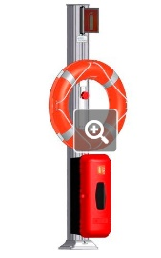Lifebuoy pedestal

Material Seawater-resistant aluminium alloy complying with 5083 H111 Lloyds Register of Shipping

Beacon Solar-powered, “Green” flashing, 360o, 1.5 nm

Protection Class IP 68

Lifebuoy SOLAS approved 24” Orange ring with 10m rescue line

Anchor bolts 4 No M18 bolts in AISI 316L

Location of delivery: Kotor, Montenegro

Warranty period 3 years

Contract completion period 90 calendar days after signing of the contract.

**SECTION 2 –BILL OF QUANTITIES/PRICED ACTIVITY SCHEDULE**

|  |  |  |  |  |  |
| --- | --- | --- | --- | --- | --- |
| **SUMMARY BILL OF QUANTITIES** | | | | | |
| **No.** | **Description** | **Unit** | **Quantity** | **Unit Price** | **Total Price** |
| 1.1 | Concrete pontoon - specification | pcs | 1 |  |  |
| 1.2 | Concrete pontoon - Anchoring | pcs | 1 |  |  |
| 1.3 | Concrete pontoon - Fittings | pcs | 1 |  |  |
| Total Price | | | | |  |
| VAT % | | | | |  |
| Grant Total including all taxes, customs and VAT | | | | |  |

**SECTION 3 - DRAWINGS**

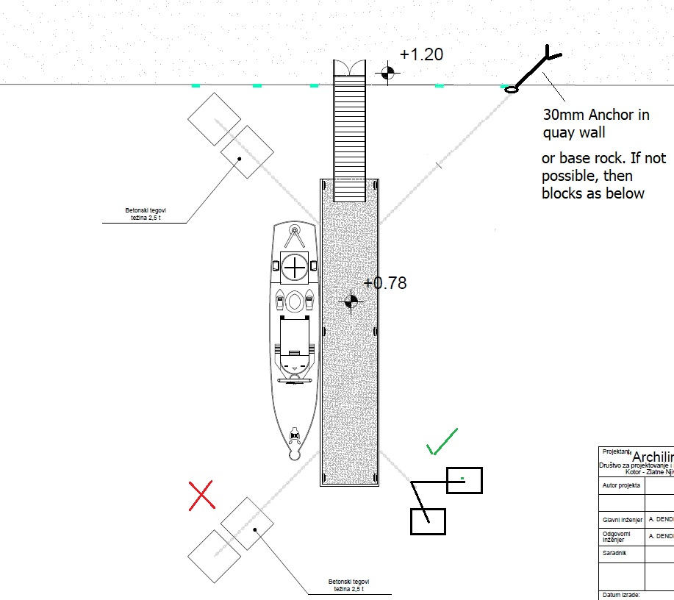

**FORM OF CONTRACT**

**Name of Country:**

**Project Name:**

Name of Contract:___________________________

Contract Number ____________________

This Contract is made this _______________ day of ________________2011 between _______________________________________on the one part (hereinafter called the Employer) and ___________ (hereinafter called the Contractor) on the other part.

Whereas the Employer has called for quotations for (name and identification number of the contract) and the Contractor has submitted a quotation for the above work and the Employer has accepted the Contractor’s Quotation dated ________ for the execution and completion of such works and the remedying of any defects therein.

Now this Contract witnesses as follows:

1. The Contractor hereby covenants to execute the works fully detailed in the Bill of Quantities included in the Contractor’s Quotation which constitute an integral part of this Contract (Annex 1) in a professional and workmanship like manner in accordance with the following Conditions of Contract:
   * 1. Remedy all defects within 30 days of notification by the Engineer in charge during the period of execution of the contract and thereafter defects notified within the defect liability period.
     2. The Employer reserves the right to terminate the contract due to unsatisfactory performance 10 days after giving a written notice. If the Contract is frustrated by the outbreak of war or by any other event entirely outside the control of either the Employer or the Contractor, the Engineer in charge shall certify that the contract has been frustrated. In such an event, both the Employer and Contractor will have a right to terminate the contract by giving 10 days notice to the other party without any financial repercussions on either side.
     3. All material and construction equipment on site, temporary works, and Works shall be deemed to be the property of the Employer if the contract is terminated due to fault of the Contractor.
     4. The Contractor will in all cases abide by the directions of the Engineer in charge.
     5. The Contractor shall submit to the Engineer in charge, a program within 7 days after signing the contract describing general methods and schedule to complete the works.
     6. Contract completion period 90 calendar days after signing of the contract.
     7. In case of variations in quantities, unit rates under the contract will be used to support the variation order. New items of work performed as ordered by the Engineer in charge will be paid at the mutually agreed rate and in case of any disagreement between the Contractor and the Engineer in charge the latter will fix the unit rates that will be binding on the Contractor.
     8. The Law governing the contract shall be applicable laws of the Government of Montenegro
     9. The Contractor shall be responsible for the safety of all the activities on the Site.
     10. During execution of works the Engineer in charge ________ (name) will carry out inspection of works at site to verify that works are executed by the Contractor in accordance with the specifications and required quality as per specifications. Engineer in charge will reject works not performed to the required specifications and the Contractor shall take immediate actions to rectify all defects in accordance with subparagraph (a) above.
     11. Either party may terminate the Contract by giving a 30 days notice to the other for unforeseen events such as wars and acts of Gods such as earthquake, floods, fires etc. In such case the payments will be made to the date of termination of contract.
     12. The Contractor is responsible for all taxes, duties, levies, customs, etc. in accordance with the laws of the [insert name of the Country].
     13. The disputes between the Employer and the Contractor arising between them under or in connection the Contract shall be resolved amicably. In the event the dispute remains unresolved either party may refer the dispute to __________(name the authority in the country such as Engineering Institute, Legal Institute, etc.) in accordance with the law governing the contract.
2. In consideration thereof the Employer covenants to pay the Contractor the contract price of ____________________ (in words and figures) in the following manner and installments:

(A) An advance payment of 15 percent of the Contract sum will be paid upon the Contractor bringing at the work site the following items and Engineer in charge certifying it: 1/ at least one half of all materials to be incorporated in the works or all materials to be consumed within three months whichever is less, and 2/ all equipment required for the construction.

(B) All four subsequent installment payments will be made at the rate of 20 percent of the contract amount. Each installment payment will be due for payment within 21 days of submission of invoice when the value of the work actually performed during the period of the required payment, calculated on the basis of unit prices and quantities, reaches 25 percent of the contract amount.

(C) The final payment of remaining 5 percent of the contract amount shall be made at the end of the liability period.

(D) Final contract value will be based on the actual quantities completed.

(E) The defect liability period will be 36 months after taking over of completed works by the Employer.

3. **Inspections and Audits**

3.1 The Contractor shall carry out all instructions of the Project Manager which comply with the applicable laws where the Site is located.

3.2 The Contractor shall permit, and shall cause its Sub-Contractor to permit, the Bank and/or persons or auditors appointed by the Bank to inspect and/or audit its accounts and records and other documents relating to the submission of the Quotation to provide the Services and performance of the Contract. Any failure to comply with this obligation may constitute a prohibited practice subject to contract termination and/or the imposition of sanctions by the Bank (including without limitation s determination of ineligibility) in accordance with prevailing Bank’s sanctions procedures.

1. **Termination**.

The Employer may terminate this Contract with at least ten (10) working days prior written notice to the Contractor after the occurrence of any of the events specified in paragraphs (a) through (d) of this Clause:

(a) If the Contractor does not remedy a failure in the performance of its obligations under the Contract within seven (7) working days after being notified, or within any further period as the Employer may have subsequently approved in writing;

(b) If the Contractor becomes insolvent or bankrupt;

(c) If the Contractor, in the judgment of the Employer or the Bank, has engaged in corrupt, fraudulent, collusive, coercive, or obstructive practices (as defined in the prevailing Bank’s sanctions procedures) in competing for or in performing the Contract.

(d) If the Employer, in its sole discretion and for any reason whatsoever, decides to terminate this Contract.

In witness whereof the parties thereto have caused this Contract to be executed the day and year first before written.

|  |  |
| --- | --- |
| Name of the Employer  ________________________  Signature (on behalf of the Employer)  In the presence of: _______________________  (Signature) Name and designation (Witness) | Name of the Contractor  _________________________  Signature on behalf of Contractor  In the presence of: _____________________  (Signature) Name and Address (Witness) |

**FORM OF QUOTATION**

_________(Date)

To: Ministry of Agriculture and Rural Development

Address: Rimski trg 46,

81000 Podgorica, Montenegro

We offer to execute the Construction of a pontoon for mooring a new inspection vessel at the Institute of Marine Biology, Ref.no. MNE-MIDAS2-8820-ME-RFQ-W-20-3.5. in accordance with the Conditions of Contract accompanying this Quotation for the Contract Price of _________________________ EUR (amount in words and numbers) (______________ ). We propose to complete the Works described in the Contract within a period of [purchaser to insert period] calendar days from the Date of Signing of the Contract. .

This Quotation and your written acceptance will constitute a binding Contract between us. We understand that you are not bound to accept the lowest or any Quotation you receive.

We hereby confirm that this Quotation complies with the Validity of the Quotation required by the Request for Quotation.

Authorized Signature:______________________________________

Name and Title of Signatory_________________________________

_________________________________

Name of Contractor:_______________________________________

Address: _______________________________________

_______________________________________

Phone Number ___________________

Fax Number, if any___________________